Visualization Project

# The Topic

Analysis of the effect of weather (temperature and humidity) on RADAR range position error calculated for aircraft surveillance.

Goal is to determine if changes in temperature, humidity and air pressure significantly affect the nominal RADAR range error used by Air Traffic Control in Australia.

# The Background

What are the data components to visualize exactly?

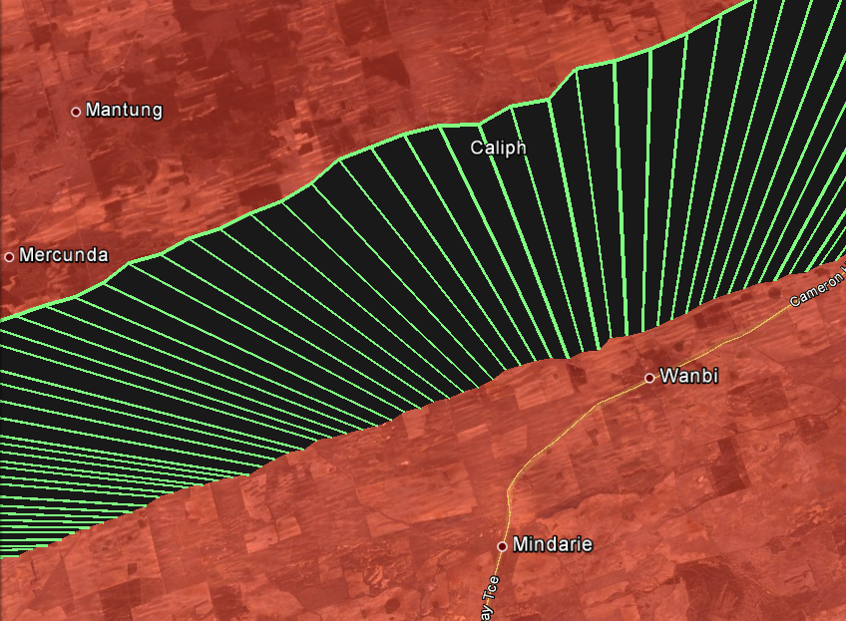

Radar measurements of aircraft at shown times

(Seconds past UTC)

85851.73

85855.71

85847.76

85839.81

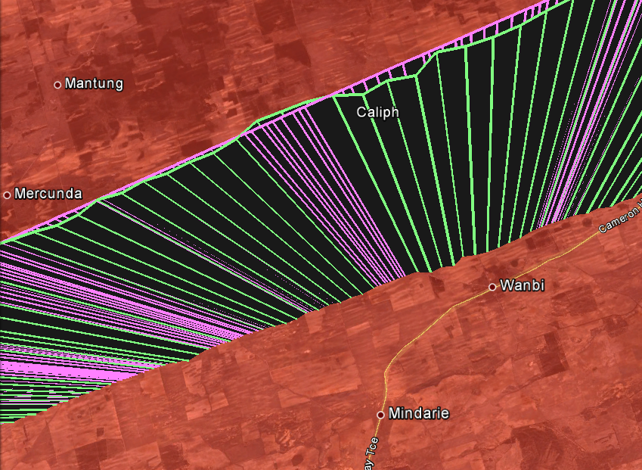

85851.73

85855.71

**1. Radar measurements (Green) on aircraft MODE S transponder at times shown with time (Seconds past UTC) for reference**

**Track reports are approximately every 4 seconds due to mechanical rotation of antenna of approx. 15 RPM**

**2. ADS-B reports (Pink) of same aircraft during same time period. These non-solicited reports are broadcast at shorter intervals (approximately every second) than Radar can acquire.**

**These positional reports originate from an onboard GPS unit and are also typically more accurate**

**3. Example of Radar Error. Where positions of both sources do not agree at same time, there is an error. This deviation is a typical example of Radar error1, and increases at further distances from the Radar**

**4. Aircraft altitude**

**This is reported separately and any error is not dependent upon Radar, and so is not considered here.**

**Radar only measures slant range to Radar, and relative bearing from it**

Figure 1 Google Earth KML track illustration showing Radar Errors (differences in ADS-B and Radar positions)

1 ADS-B errors can be detected and discarded, so it is a Radar error.

This Radar error is measured in average metres of increase per NM, called Range Error Gain. So after 1 NM it is 1 unit of error , 2 NM it is 2 units, 3 NM it is 3, etc

Due to Radio Frequency signals travelling through a non-vacuum medium, the speed will slow depending on the medium density. Radar ranges are calculated here by time-of-flight between Radar and transponder signals from the aircraft. This time difference is converted to distance using a constant speed of light value (approximately half that of classical speed of light in a vacuum).

This speed value used, c, is constant and based on an average atmospheric density, which is in reality quite variable especially at lower elevation detection angles, where the atmosphere is denser and the signal travels quite a distance through it (up to. 256 Nautical Miles (NM), or approx. 475 kilometres). Aircraft are to be separated laterally by at least 5NM at 40,000ft or 3NM at lower altitudes.

**Does the variability in atmospheric environment vary this averaged value c enough to significantly effect the Radar error ?**

* For example, a variation of 10% could produce an error which impinges on the minimum separation.
* This is the hypothesis to analyse and visualise. Further background data is included in the References, which not strictly necessary to read, but may clarify some details.

Note that the error is most significant

* + - Where aircraft are furthest from the Radar, as the signal has to propagate the furthest, and induce the largest error.
    - Where aircraft are at a low elevation to the Radar, as the atmosphere is denser and the temperature and humidity profile is consistent over that range

Also of interest for this problem are

* + - Comparison at different geographic latitudes (subtropical vs temperate)
    - When there is an increase in air traffic (require minimal surveillance error)
    - When there are extreme or varied atmospheric conditions (summer vs winter, wet season vs rainy season, night vs day)

Interestingly the last two points are coincident. That is, the two busiest times for air travelling public for Australia is during Easter (entering Winter) and Christmas (Summer)

# The Radar Data

The two Enroute Radars at Cairns (Hahn Tableland) and Melbourne (Mount Macedon), are both identical units, are selected because :

* + - Large physical separation in latitude for differing weather conditions
    - Both have large number of daily flights in detection range

The comparison of Radar and ADS-B goes through several model translations, as described in the References. Also included there are more details on the derivation. Below contains some of those calculated components, and required criteria they must meet, or relevant usage, for consideration in the data set.

|  |  |  |
| --- | --- | --- |
| Component | Description | Usage/Criteria |
| Range Error Gain | This is the average increasing positional error that increases by this amount (in metres) every Nautical Mile of range | This is the prime error measurement for Radar inaccuracies. This is the assumed dependent variable. |
| Elevation | This is the vertical angle of the horizonal and the aircraft to the Radar | Require elevation to be 10 degrees or less, for error to be noticeable. |
| Overall Range | This is maximum range less minimum range of each track to the Radar | Require Track to have covered at least 200NM for a varied data set |
| Entries | The number of track reports detected in this analysis. | Require at least 100 entries for a decent population sample (Typically 500-1500 reports) |
| Temperature | This is the BOM temperature (units Celsius) | Compare variability against Range Gain for trend. |
| Mean Sea Level (MSL) Pressure | This is the Air Pressure at Sea Level (units hPa) | Compare variability against Range Gain for trend. |
| Relative Humidity | Percentage of moisture in the air | Compare variability against Range Gain for trend. |

# The Weather Data

BOM stores last 14 months of data, which I retrieved in March 2022 for the locations:

* + - Melbourne Airport
      * <http://www.bom.gov.au/climate/dwo/IDCJDW3049.latest.shtml>
    - Cairns Airport
      * <http://www.bom.gov.au/climate/dwo/IDCJDW4024.latest.shtml>

These data files are also located in my git repository <https://github.com/yetanotherpassword/cosc3000>

From this dataset, the following data is utilized

Temperature (C)

MSL Pressure (hPa)

Relative Humidity (%)

These free datasets also only provide two readings for the day, one at 9am and one at 3pm. More detailed hourly datasets are available for a cost but were not purchased for this exercise. So for daily comparison the average of these are used. For individual track comparison the closer temporal value is used.

Table Summary of extremes for the 3 environmental variables in BOM data (2021-03-01 to 2022-02-28) for Melbourne

|  |  |  |  |  |  |
| --- | --- | --- | --- | --- | --- |
| Metric | Metric | Temp | Pressure | Humidity | Date |
| Temp  (Celsius) | 9am Min | 19.1 | 1018.4 | 59 | 20/06/2021 |
| 9am Max | 33.1 | 1004.1 | 49 | 05/01/2022 |
| 3pm Min | 21.3 | 1017.9 | 91 | 09/08/2021 |
| 3pm Max | 37 | 1000.1 | 33 | 26/02/2022 |
| MSL Pressure  (hPa) | Min 9am MSL Pressure | 24.6 | 1001 | 80 | 01/03/2021 |
| Max 9am MSL Pressure | 23.6 | 1022.5 | 71 | 09/09/2021 |
| Min 3pm MSL Pressure | 22.3 | 997.5 | 95 | 01/03/2021 |
| Max 3pm MSL Pressure | 25.6 | 1020.0 | 53 | 08/09/2021 |
| Relative Humidity (%) | 9am Min | 23.9 | 1017.6 | 32 | 20/09/2021 |
| 9am Max | 23.7 | 1011.9 | 98 | 19/04/2021 |
| 3pm Min | 28.4 | 1008.3 | 21 | 16/10/2021 |
| 3pm Max | 24.1 | 1011.7 | 96 | 20/04/2021 |

# The Analysis Method

A top-down analysis is performed. That is trends are to be explored of the error against the atmospheric metrics over the whole year. If there is no obvious correlation with the change in error to any of these metrics, we then drill down into the details of particular days. The specific days will be where there are large changes in the error and/or large changes in one particular atmospheric metric, and any correlation is then attempted.

Finally, a Primary Component Analysis is performed to decisively determine if there are co-dependence within in the system and by what proportions.

## The Big Picture

If we plot the individually calculated Range Error Gain of each criteria compliant track, against every day over one year, and colour code each against the 3 environmental daily averaged metrics (Temperature, Humidity and Atmospheric Pressure) we would see for Cairns :

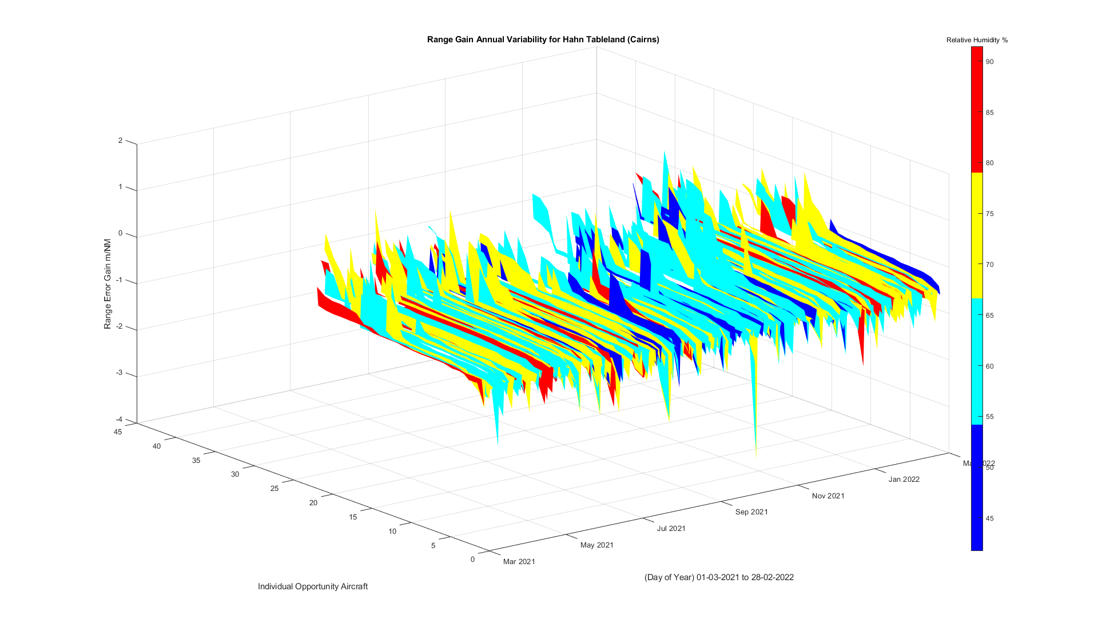

Figure 2 Range Gain Distribution over 12 months colour coded to Relative Humidity for Cairns

## Notes

* For each of the 3 environmental metrics, they are colour coded into 4 equal portions over the total minimum and maximum values in the given data set. This is done to visualise easier value ranges.
* These graphs are also available as PDF animations in References [4] [5], providing multiple viewing angles.
* The tracks are sorted in ascending order of its individual range gain calculation. This is done to better see the features, as their order does not matter. So there is no meaning in the ascension of the Range Error Gain across the number of tracks.
* It is important to only look for correlation with the height (ie Z axis) with colour first. There is not much extra knowledge in colour against the X or Y axis, i.e. summer is hot and winter is cold, or there are less flights in low pressure cyclone events.

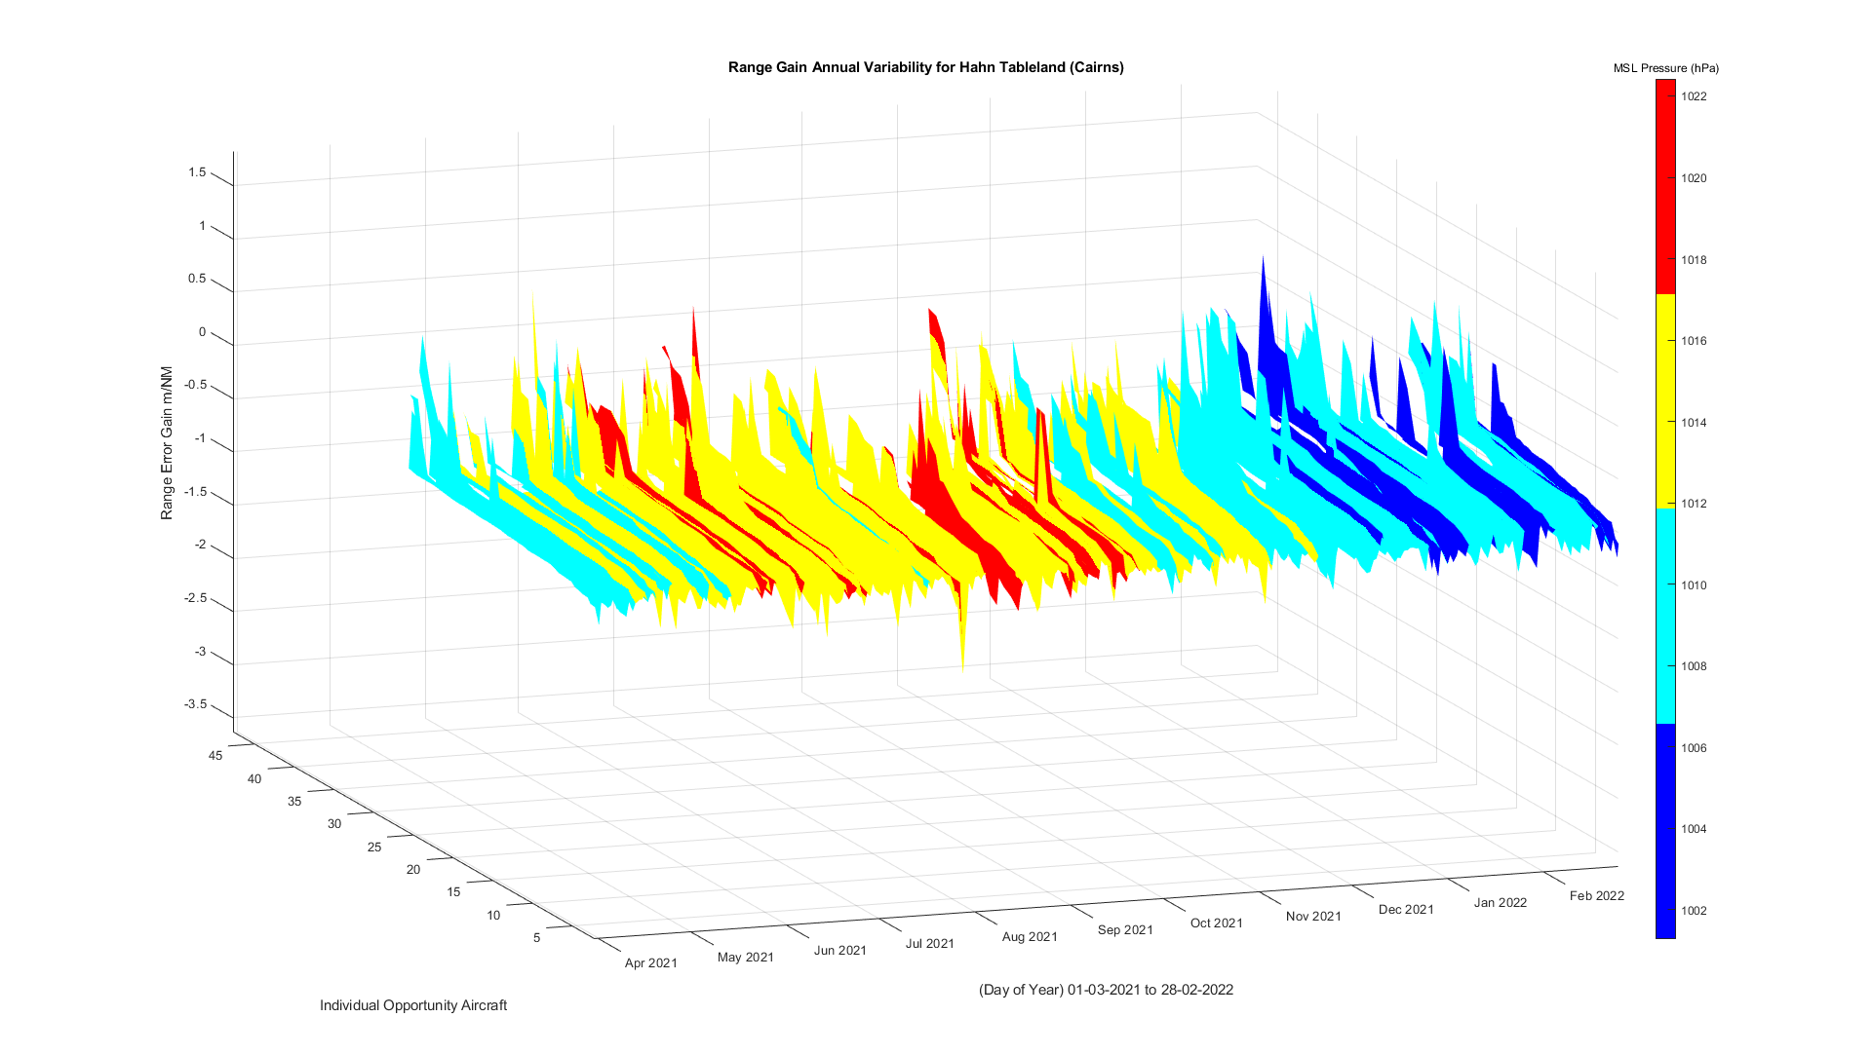

Figure 3 Range Gain Distribution over 12 months colour coded to MSL Pressure for Cairns

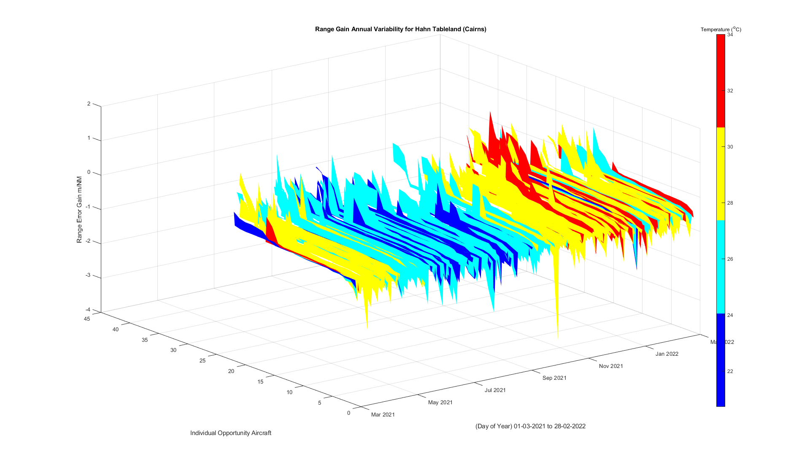

Figure 4 Range Gain Distribution over 12 months colour coded to Temperature for Cairns

## 

Figure 5 Range Gain Distribution over 12 months colour coded to Relative Humidity for Melbourne

## 

Figure 6 Figure Gain Distribution over 12 months colour coded to MSL Pressure for Melbourne

## Observations

From these 3 graphs there is no obvious trend over both sites. That is, all peaks troughs and valleys appear to cut across all colour ranges of each atmospheric metric.

Although there seems to be greater average daily variability in Relative Humidity than MSL Pressure or Temperature at both sites.

We see in reference [2] that the main factors affecting RF refraction is, in order of importance, Humidity, Temperature and Atmospheric Pressure. And in fact the Atmospheric Pressure is quite insignificant, so for the drill down we will not consider this. Also increased refraction occurs when there is HIGH humidity and LOW temperature.

Comparing both sites for that 365 period, we see Melbourne had the most extreme of both case for maximum and minimum refraction conditions. This occurred at :

* 3pm 20/07/2021 with 8.2O at 92% Relative Humidity (Expected LOW Radar Error)
* 3pm 31/12/2021 with 36.9O at 15% Relative Humidity (Expected HIGH Radar Error)

So we will continue the analysis only with Melbourne Radar on these days.

## The Deep Dive

Here we examine the Radar Range Error (from which Radar Range Gain Error is calculated) of individual tracks for the two days in question, and for those tracks that were in the air within an hour either side at 3pm.

This is a more specific analysis and should show a snapshot of the error effects during this time. It will not show any long term trends, but an empirical way to test the hypothesis of this analysis.

Here we will compare two polar plots from Melbourne Radar, that show

* In time, the day 20/07/2021 with low temperature and high humidity (expect larger error)
* In time, the day 31/12/2021 with high temperature and low humidity (expect smaller error)
* Geographically, the Radar centred at the origin and,

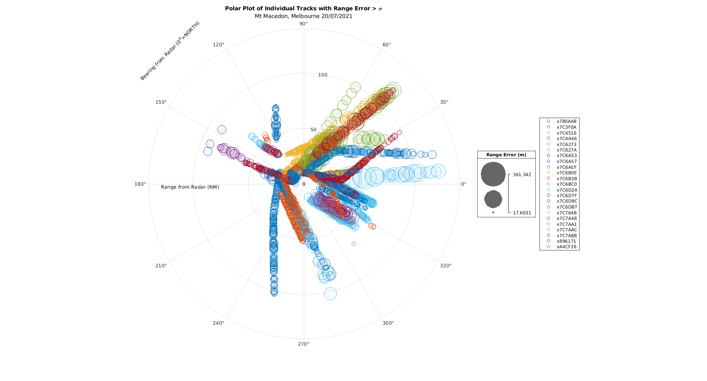

Figure Melbourne radar 20/07/2021 at 2-4pm traffic when at 3pm was 8 C and 92% RH

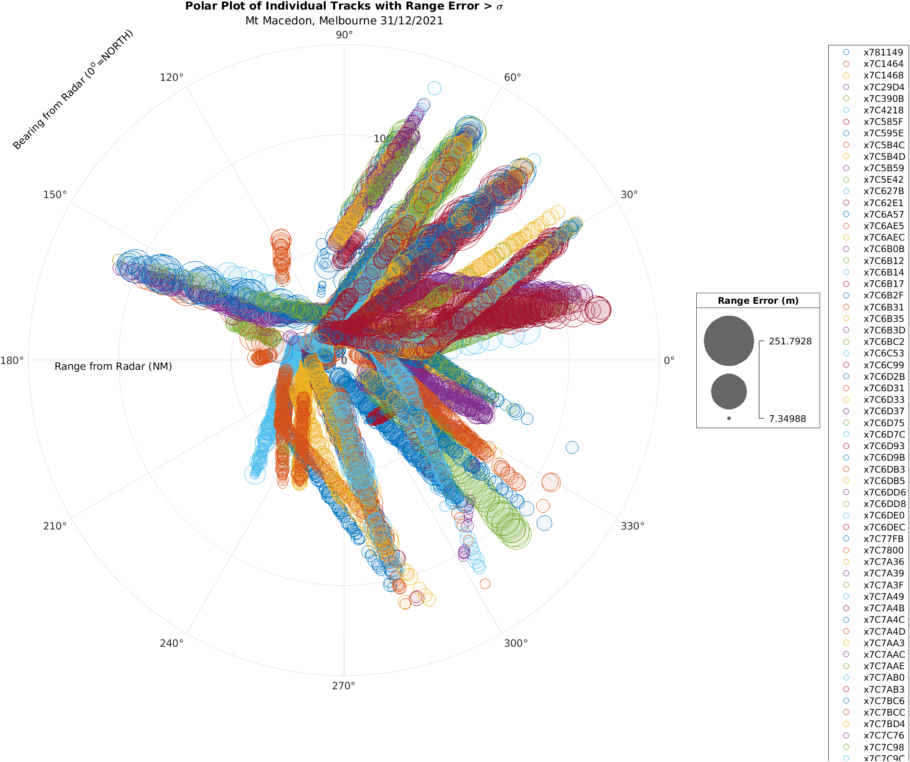

Figure Figure 7 Melbourne radar on 31/12/2021 at 2-4pm traffic when at 3pm was 39 C and 15% RH

* All Range Error is plotted for each track report as circles, and
* The size of the circle represents each Range Error calculation, and is scaled accordingly
* The colours represent the actual aircraft, shown in the legend with their 6 digit hexadecimal MODE S Identifier. Nothing or real importance to note other than aircraft that do not start with ‘x7C’ are international aircraft and so may not have as strict regulation in their country as Australia does (so their avionics could be less reliable and add to an error measurement)
* Only the tracks that flew between 2pm and 4pm to ensure relatively consistent weather conditions
* Only the Range Errors that were larger than its standard deviation for that aircraft are plotted, otherwise there would be many more plots and much hard to discern. These smaller errors are not of importance anyway.
* These polar plots also show the direction of errors, for example if a storm is approaching perhaps that sector shows larger errors.

## Observations

From these 2 graphs the aim is to determine if there is a discernible difference in circle size between the two days. This is difficult to judge as can be seen the many different aircraft show a different error profile.

This could be due to the different types of aircraft (subtle difference in avionics e.g. GPS fix should be less than 200 mS old), size of aircraft, altitude they are flying, their flight profile, antenna location etc. One thing that can be noticed is the minimum and maximum errors for these respective days are recorded in their legend.

The minimum error has an increase of approx. 60%, and maximum has an increase of 30% on the cold but humid day, than the hot dry day. This is a positive step in the hypothesis confirmation. However this is not conclusive as they could be of low distribution. That is, may be just some rouge points at these extremes.

As mentioned previously the error is calculated by comparison of more reliable truth data. It is this error we will examine now. I have discovered one common aircraft was in the vicinity on both days. This should show a reasonably common and stable state (assuming no avionics were replaced or upgraded significantly during those 6 months), ideally several aircraft would be better.

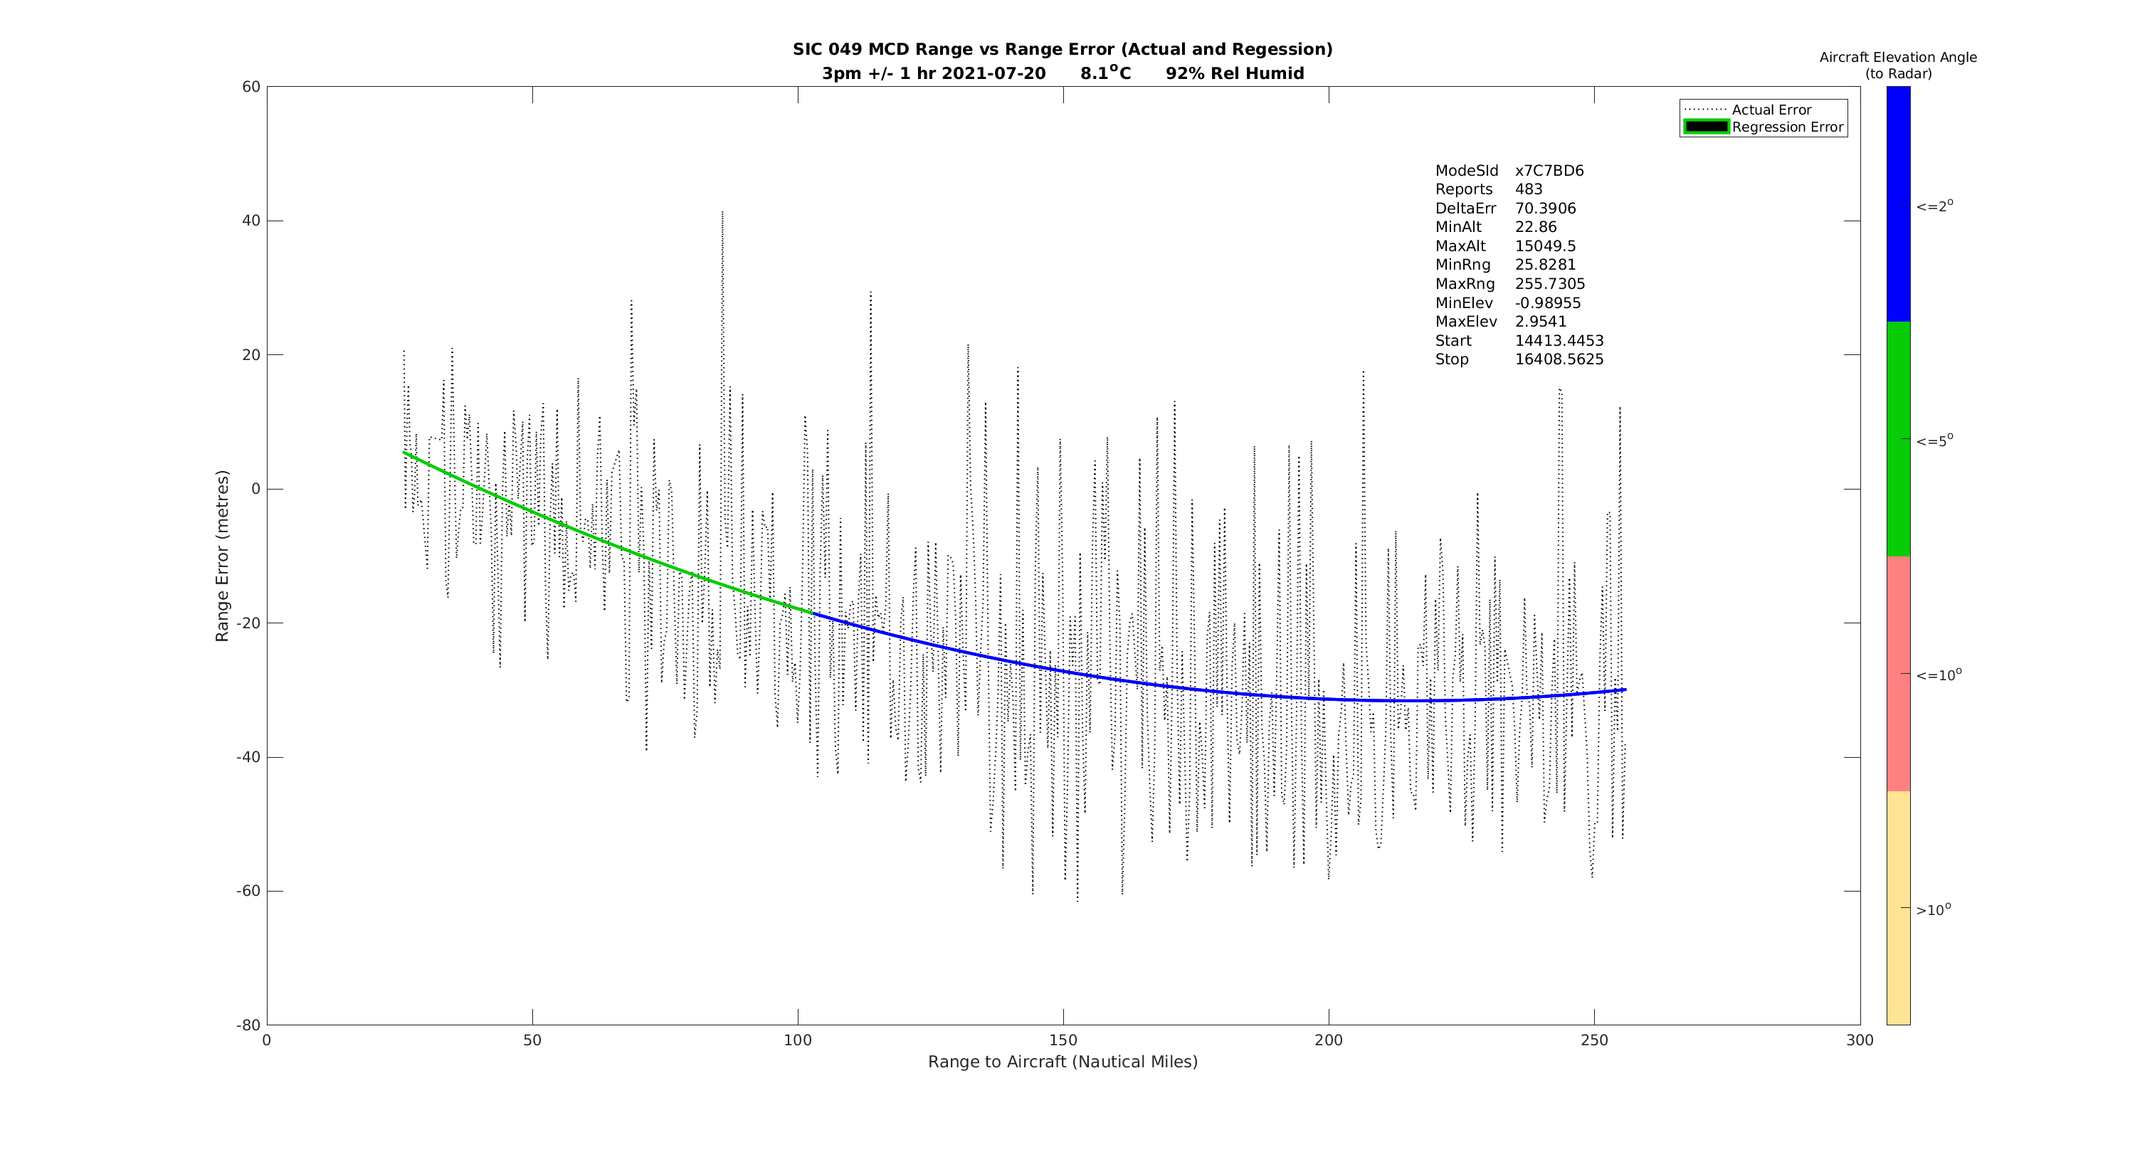

Figure Aircraft x7C7BD6 Radar Range Error analysis on 20-07-2021

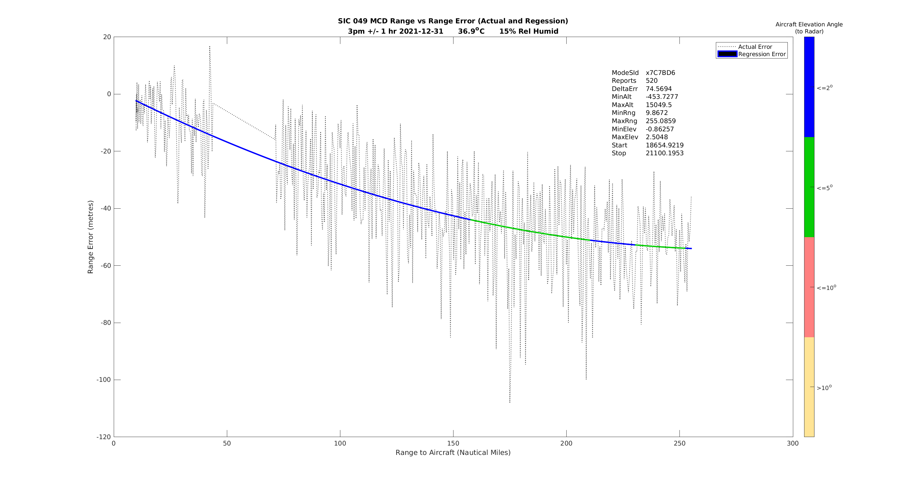

Figure Aircraft x7C7BD6 Radar Range Error analysis on 31-12-2021

## Observations

Firstly we that, there is a lot of noise in the ‘signal’, not just from atmospheric activity but many other factors, as mentioned above and also antenna orientation, electrical noise in transmitted and received local environments, multipath reflections from other aircraft or geography, RF interference from ground based transmitters that may be in the line of sight, and so on. This is a good example demonstrating the difficulty of getting high resolution of this error measurement.

If we perform a linear regression to a second order polynomial, as we know RF signal strength obeys the inverse squared decay rule, with respect to distance, we can find a curve of best fit.

If we interpolate this between our maximum and minimum ranges (and extrapolate if required) we then the curved line as shown above. The colour coding indicates the elevation and at all times it stays below our 10O criteria for both periods.

So if we take the line reading of Range Error at 256 NM it would appear to be in order of around

* 55 metres of error on 31/12/2021 and
* 35 metres of error on 20/07/2021

This is not positive for the hypothesis, as we expect a higher error on the colder humid day (20/07/2021) and lower error on the hotter less humid day (31/12/2021).

## Principle Component Analysis

To demonstrate any interdependence between our variables, PCA is used.

Here the whole year period is analysed across the 3 environment variables (re-including MSL Pressure) and over the two sites (re-including Cairns site)

Using 4 variables, we have 4 components and so plotted as 2 x two dimensional graphs below for both sites. Also Plotted here are the Scree Plots

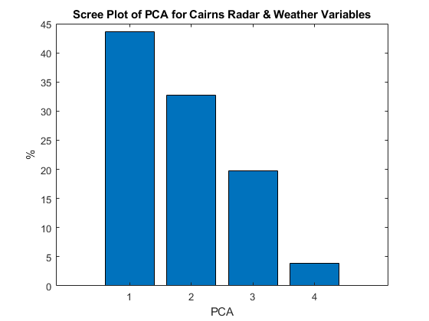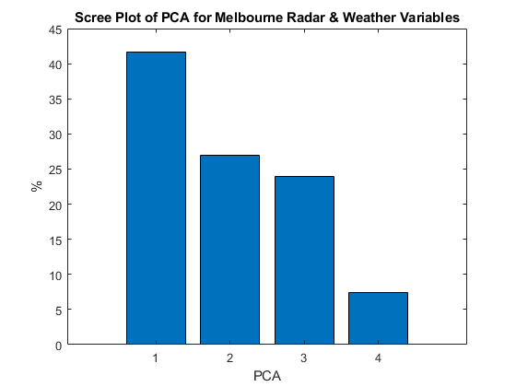

These graphs are similar and shows the co-dependence and percentage each contributes to the error. The error (PCA1) itself is the main component obviously, for any interpretation of the variability, with Temperature (PCA 2), Humidity (PCA 3) and MSL Pressure (PCA 4) contributing the least, as expected, although I did expect Humidity to have a larger impact than temperature, though for Melbourne at least, where there was the most variability they are only within a few percent.

# Conclusion

My conclusion is indeterminate at best. I can see a relationship with weather and Radar error, but it is not simple to model in a real world scenario to a resolution that is really needed for a determination.

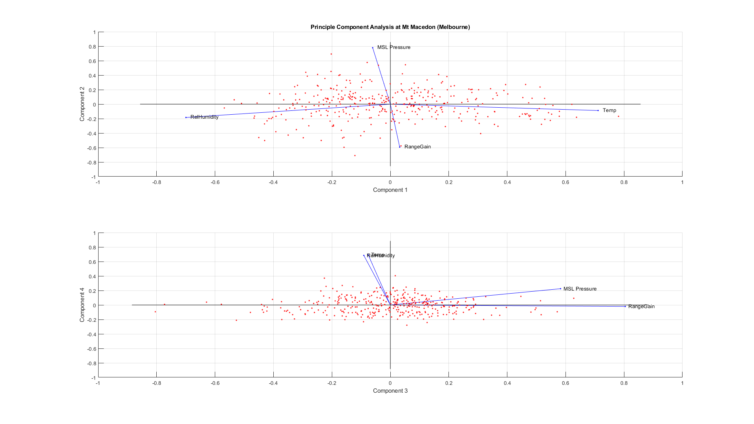

Figure PCA of Melbourne Radar over 12 months for Range Gain Error, Temperature, Relative Humidity and MSL Pressure

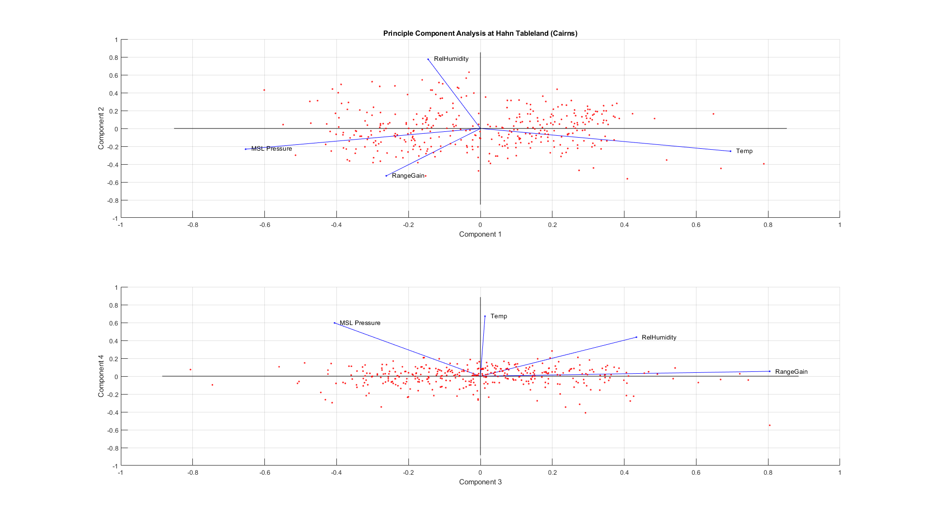

Figure PCA of Cairns Radar over 12 months for Range Gain Error, Temperature, Relative Humidity and MSL Pressure

# Self Assessment

Primarily disappointed with an inconclusive result. Would have like to done some more statistical analysis on the data. One issue I am aware of is the ADS-B latency that can give a GPS solution in the order of seconds late. Primarily in general aviation, it causes a large error to be hidden in the truth data. Even so at the maximum value of the minimum regulated latency of 200mS latency that can generate an error in the order of 50-60m if travelling at 1000+ km/h. So it is a hard problem to resolve unless using a calibrated aircraft flying a specific pattern to remove some of these unknowns.

My progress of completion was delayed somewhat with a bad case of Covid-19 in the final weeks before submission. Along with some addition post processing I had to do to collate the data into the final format, this effort was under estimated to complete.

Also underestimated was the time taken to process 12 months of data, my script was run on a Proliant DL360 Gen 9 with 92 Gb of RAM but still took about 1.5 days to process for each site. In the end I only used some of this data, as daily graphs, as while I waited I progressed other approaches. Mainly to use the summarised Radar data instead, of reproducing just the track analysis over the 9am and 3pm windows.

I would have preferred to use hourly BOM data, but this is not available for no cost. Their free data only has those two data points, and while averaging them together for use in daily processing was not ideal, it did better show some details in the 3D surface plots over the year, that humidity average is much more variable over the weeks than Temperature or MSL Pressure.

Another possible issue with my data was the period included a majority of lockdown in 2021. While some domestic and international flights were still occurring (including cargo flights) a large portion of the normal traffic was absent. Although the polar graph on New Years Eve did show the busy period was picking up, as the lockdowns were ending.

This also may have provided me with the only common track for the final track report analysis. As the reduced activity made for less flights. I would have preferred a bigger population to compare, though there were many more aircraft to compare with, getting to the level of resolution I would have liked, I really preferred to use the same aircraft.

There was also an enormous amount of effort in the Matlab coding, and perhaps too much explanation of background information. I have moved an entire chapter to my repository from this document as while useful and needed to explain some sections, it is there as supplementary. Basically, was difficult to explain the topic details in a concise form. Had I the time again, I would have chosen a more succinct topic, that has been analysed to death, such as a MNIST dataset. But I also feel that was an easy way out.

Hopefully I have got some points across to the reader on the analysis, it was difficult to summarise in only 3-4 pages, especially with the graphics inserted, as I wished them to be large for easier viewing. While not satisfied with the outcome, I would like to revisit it again in my own time at a later stage, hopefully with a fresh approach and some more detailed BOM data.

Apologies for the long read.

# Appendix – References

[1] Indra En Route Radar (Manufacture Specification)

<https://www.indracompany.com/sites/default/files/indra-monopulse_secondary_surveillance_mode_s_radar.pdf>

* Resolution : 14.5 metres (1/128 NM)
* Max Range : 256 NM
* Max Altitude : 66,000 ft

[2] p8 “Atmospheric Refraction of EM Waves” LCDR Bruce Ford <https://www.met.nps.edu/~psguest/EMEO_online/module4/Atmospheric_Refraction_of_EM_Waves.doc>

[3] ATC Primer by Allan Campton <https://github.com/yetanotherpassword/cosc3000/blob/main/docs/Appendix%20Primer.pdf>

[4] Cairns 3D Surface Rotation Movie <https://github.com/yetanotherpassword/cosc3000/blob/main/pics/Cairns%20Graph%20Animation.pdf>

[5] Melbourne 3D Surface Rotation Movie <https://github.com/yetanotherpassword/cosc3000/blob/main/pics/Melbourne%20Graph%20Animation.pdf>